#VoteArtsAB Social Media Copy

FACEBOOK:
What are the arts worth to you? Despite increased budgets, high inflation, and growing population, the Alberta Foundation for the Arts funding has been slashed by 27% since 2009. This funding is crucial to the health of Alberta arts and culture, which has also been decimated by Covid-19.
@VoteArtsAB is asking for an increase to double the AFA budget in three years, or an annual increase of $8.5 million for the next three years – peanuts (0.0124%) from a budget of over $68 billion.
More than 1 in 3 Albertans attend arts events each year. The arts contribute almost $5 billion to the economy annually and employ over 46,000 Albertans.
To make your voice heard, text ARTS to (587) 875-5751 to send a letter to party leaders requesting that the AFA budget be increased to catch up with inflation and population increases. For more information visit VoteArtsAB.com or the link in our profile.
On Election Day, vote for arts in Alberta. #VoteArtsAB

The Alberta arts community needs your help! Despite increased budgets, high inflation, and growing population, the Alberta Foundation for the Arts funding has been cut by 27%, almost $10 million, since 2009. This funding is crucial to the health of Alberta arts & culture, which has also been hurt by Covid-19. Let party leaders know that Albertans love the arts!
Text ARTS to (587) 875-5751 to send a letter to all party leaders requesting that the AFA budget be doubled in three years to catch up with inflation and population increases. It’s a non-partisan way to let leaders know that the arts matter to voters like you. For more information visit VoteArtsAB.com or the link in our profile.
On Election Day, vote for arts in Alberta. #VoteArtsAB @VoteArtsAB

Are you an Alberta resident who cares about the arts? Ahead of the upcoming election, let's make sure our political leaders hear our voices and know the importance of funding for the arts. We are asking to double the AFA budget over the next three years. Simply text ARTS to 587-875-5751 to send an email to every party leader asking them to pledge to increase funding to the AFA in support of Alberta artists and arts organizations. Let's make sure the arts continue to thrive in our province! #VoteArtsAB @VoteArtsAB

Do you know that the Alberta Foundation for the Arts funding has been cut back by 27% (almost $10 million) since 2009? This funding is crucial to the health of Alberta arts and culture, which has also been decimated by Covid-19. We are asking to double the AFA budget over the next three years – a small drop in the bucket for funding that can make an enormous difference! Join us by texting ARTS to 587-875-5751 to send an email to every party leader asking them to pledge to increase funding to the AFA in support of Alberta artists and arts organizations. Let's show our support for the arts in Alberta! #VoteArtsAB

Let's make sure the arts continue to thrive in Alberta! @VoteArtsAB is asking to double the AFA budget over the next three years – a small investment that will have enormous impact. With a budget of over $68 billion, an additional one one-hundredth of one percent of the budget a year (0.0124%) is all we are asking to support the arts in our province! Simply text ARTS to 587-875-5751 to send an email to every party leader asking them to pledge to increase funding to the AFA in support of Alberta artists and arts organizations. Join us and let's make a difference for the arts! #VoteArtsAB
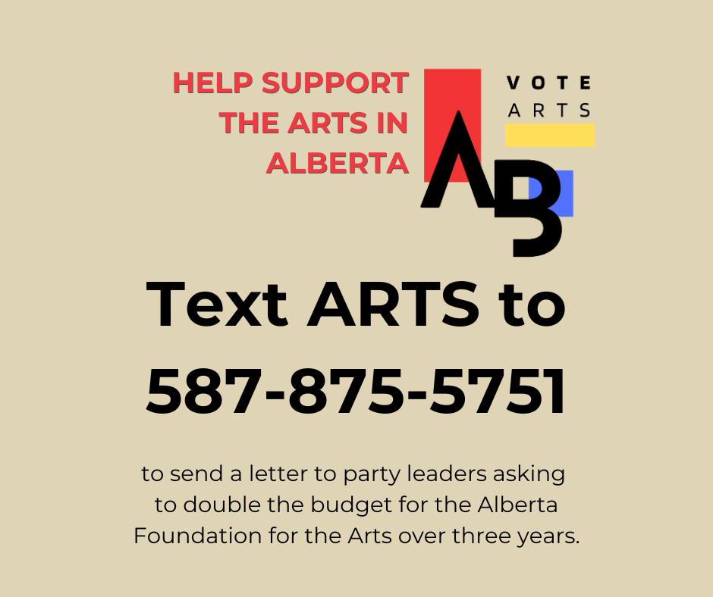
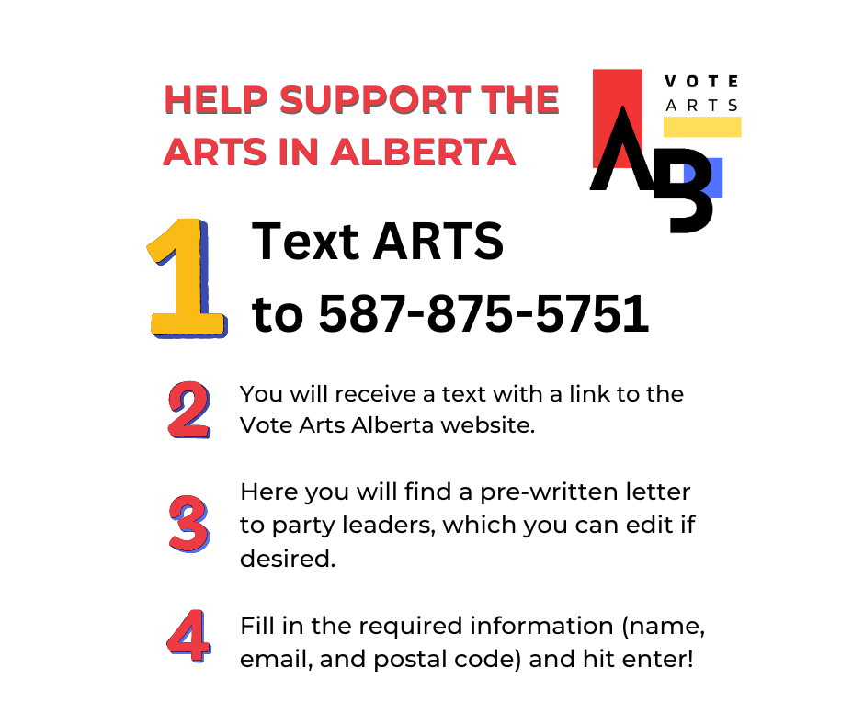
INSTAGRAM:
What are the arts worth to you? Despite increased budgets, high inflation, and growing population, the Alberta Foundation for the Arts funding has been slashed by 27% since 2009. This funding is crucial to the health of Alberta arts and culture, which has also been decimated by Covid-19.
@VoteArtsAB is asking for an increase to double the AFA budget in three years, or an annual increase of $8.5 million for the next three years – peanuts (0.0124%) from a budget of over $68 billion.
More than 1 in 3 Albertans attend arts events each year. The arts contribute almost $5 billion to the economy annually and employ over 46,000 Albertans.
To make your voice heard, text ARTS to (587) 875-5751 to send a letter to party leaders requesting that the AFA budget be increased to catch up with inflation and population increases. For more information visit VoteArtsAB.com or the link in our profile.
On Election Day, vote for arts in Alberta. #VoteArtsAB

The Alberta arts community needs your help! Despite increased budgets, high inflation, and growing population, the Alberta Foundation for the Arts funding has been cut by 27%, almost $10 million, since 2009. This funding is crucial to the health of Alberta arts & culture, which has also been hurt by Covid-19. Let party leaders know that Albertans love the arts!
Text ARTS to (587) 875-5751 to send a letter to all party leaders requesting that the AFA budget be doubled in three years to catch up with inflation and population increases. It’s a non-partisan way to let leaders know that the arts matter to voters like you. For more information visit VoteArtsAB.com or the link in our profile.
On Election Day, vote for arts in Alberta. #VoteArtsAB @VoteArtsAB

Are you an Alberta resident who cares about the arts? Ahead of the upcoming election, let's make sure our political leaders hear our voices and know the importance of funding for the arts. We are asking to double the AFA budget over the next three years. Simply text ARTS to 587-875-5751 to send an email to every party leader asking them to pledge to increase funding to the AFA in support of Alberta artists and arts organizations. Let's make sure the arts continue to thrive in our province! #VoteArtsAB @VoteArtsAB

Do you know that the Alberta Foundation for the Arts funding has been cut back by 27% (almost $10 million) since 2009? This funding is crucial to the health of Alberta arts and culture, which has also been decimated by Covid-19. We are asking to double the AFA budget over the next three years – a small drop in the bucket for funding that can make an enormous difference! Join us by texting ARTS to 587-875-5751 to send an email to every party leader asking them to pledge to increase funding to the AFA in support of Alberta artists and arts organizations. Let's show our support for the arts in Alberta! #VoteArtsAB

Let's make sure the arts continue to thrive in Alberta! @VoteArtsAB is asking to double the AFA budget over the next three years – a small investment that will have enormous impact. With a budget of over $68 billion, an additional one one-hundredth of one percent of the budget a year (0.0124%) is all we are asking to support the arts in our province! Simply text ARTS to 587-875-5751 to send an email to every party leader asking them to pledge to increase funding to the AFA in support of Alberta artists and arts organizations. Join us and let's make a difference for the arts! #VoteArtsAB
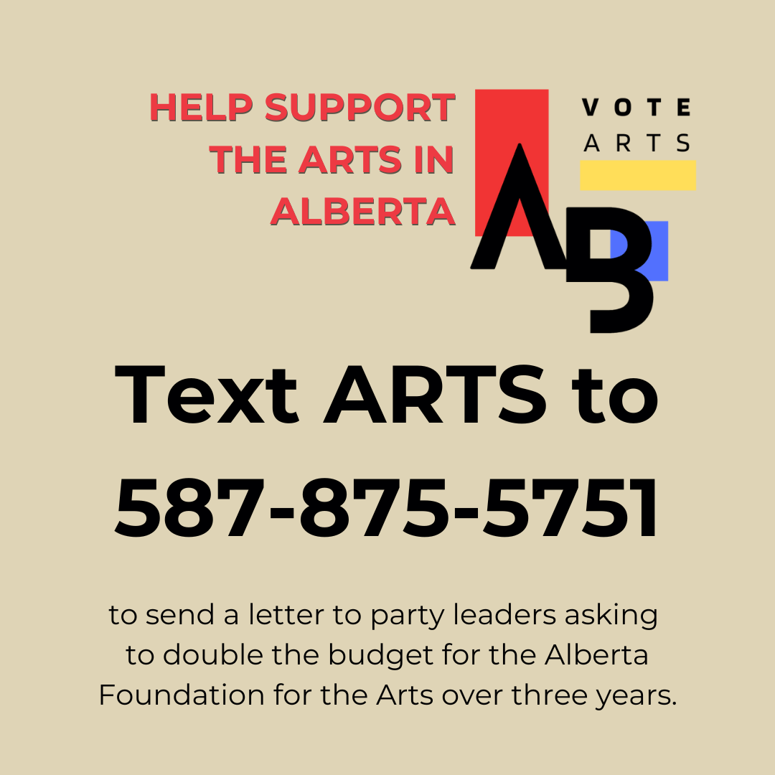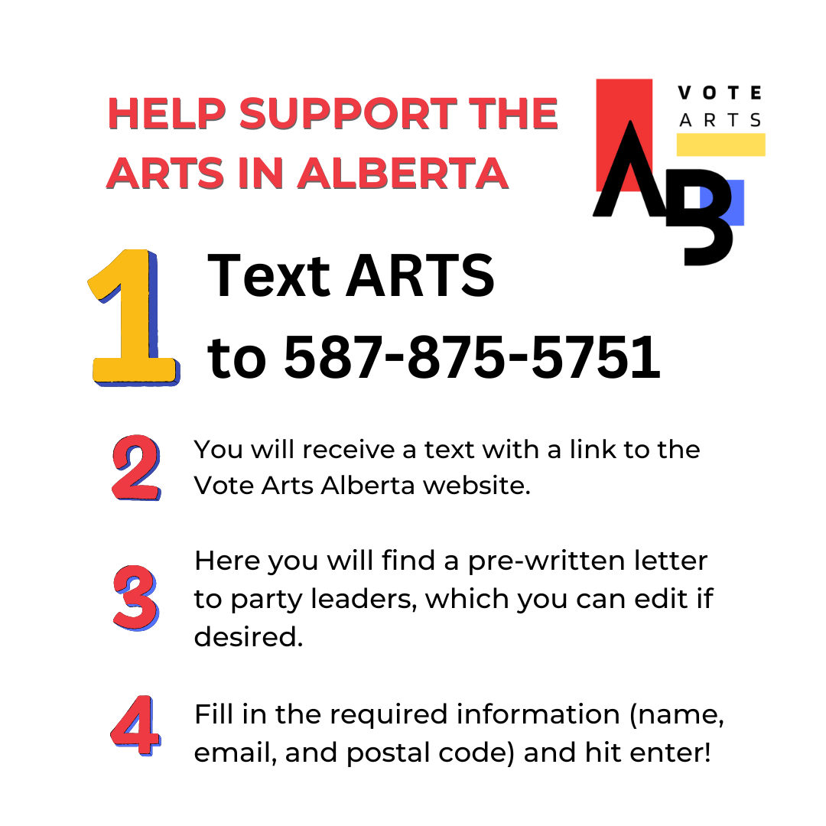
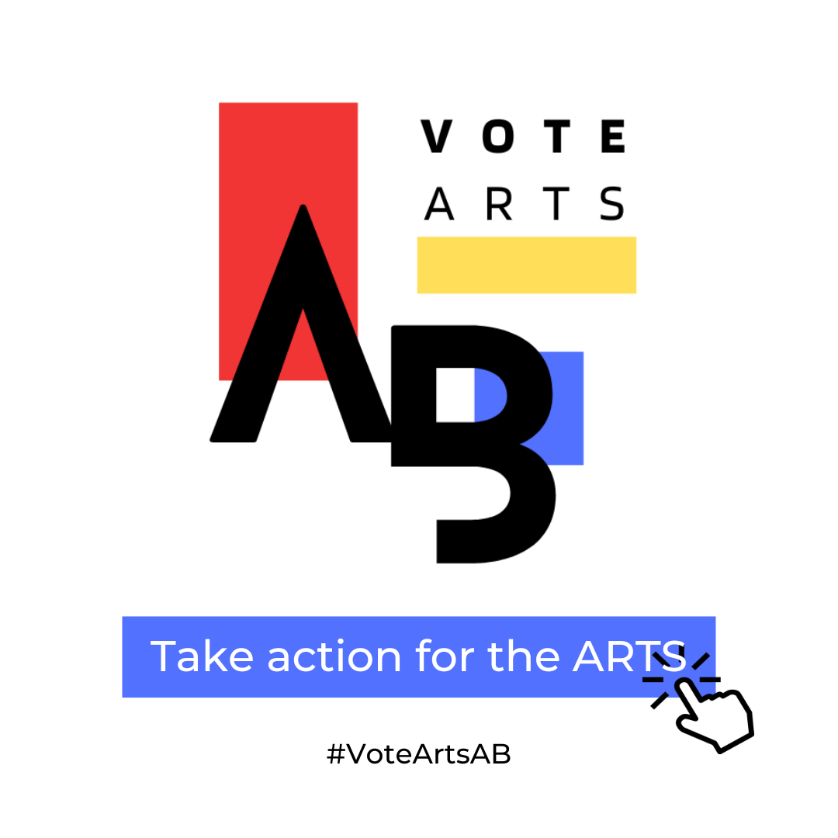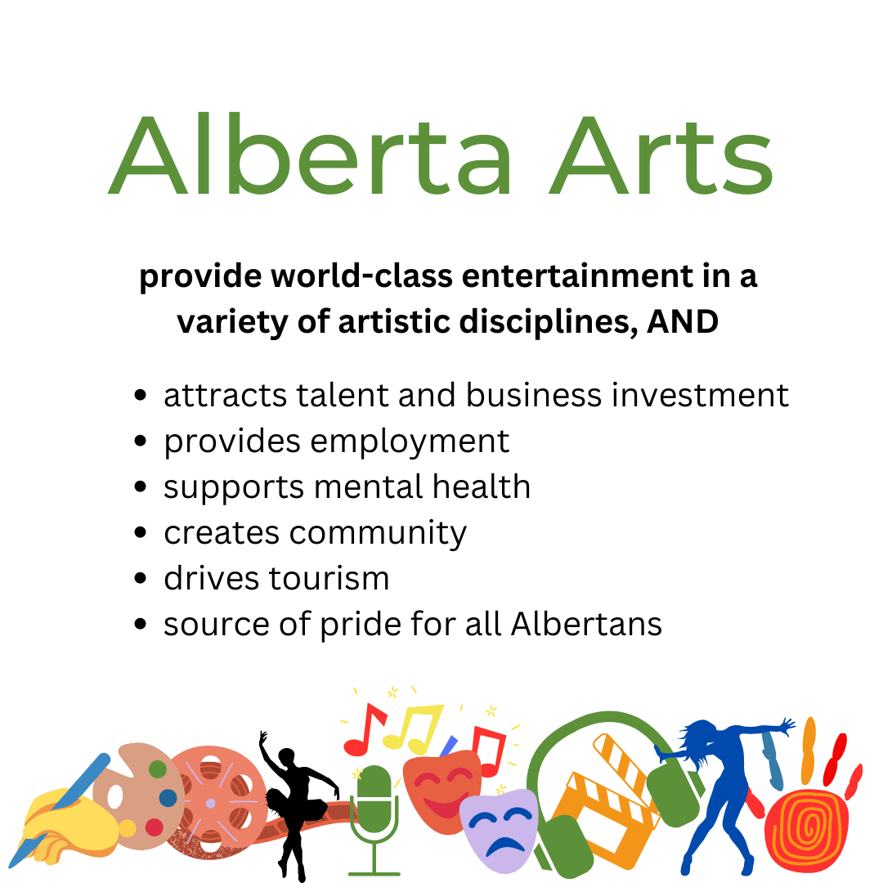

TWITTER:
Albertans love the arts! But arts funding has been cut 27% over 13 yrs, and we are losing talent and jobs. Text ARTS to (587) 875-5751 to send a letter to party leaders asking to increase the arts budget. Show them arts matter to voters like you. #VoteArtsAB

Help support the arts in Alberta by texting ARTS to 587-875-5751 to ask political leaders to pledge to increase funding to the Alberta Foundation for the Arts or visit thenonprofitvote.ca/votearts #VoteArtsAB #SupportTheArts #AlbertaArts

Did you know that arts funding in Alberta has been cut by 27% since 2009? Join us in supporting VoteArtsAB's call for increased funding by texting ARTS to 587-875-5751 or visit thenonprofitvote.ca/votearts. #AlbertaArts #SupportTheArts #VoteArtsAB

The arts are an important part of Alberta's culture and economy, and they need our support! Join us in calling for increased funding for the Alberta Foundation for the Arts by texting ARTS to 587-875-5751 or visit thenonprofitvote.ca/votearts. #SupportTheArts #VoteArtsAB #AlbertaCulture

Alberta's arts and culture sector has been hit hard by COVID-19, and they need our help now more than ever. Join us in advocating for increased funding for the Alberta Foundation for the Arts by texting ARTS to 587-875-575 or visit thenonprofitvote.ca/votearts. #SupportTheArts #VoteArtsAB #AlbertaStrong

Every voice counts! Join us in advocating for increased arts funding in Alberta by texting ARTS to 587-875-5751. Let's make sure our political leaders know how important the arts are to our province. #AlbertaArts #VoteArtsAB #SupportTheArts

Show your support for the arts! Provincial arts funding has been cut 27% over 13 yrs, and we are losing talent and jobs. Text ARTS to (587) 875-5751 to send a letter to party leaders asking for increased arts funding. Show them arts matter to voters like you. #VoteArtsAB

